IPE Depression-Suicidality Patient Summary

Patient Summary

Name: Rodrigues, Generosa  Age: 32  DOB: 3/19/1990  MRN: 5232062  DNR: No  Healthcare Proxy: Yes  Admitting Weight: 100 lbs.  Height: 63 inches  BMI: 17.7  PMH:  PSH: C-section x3 | DEMOGRAPHICS  Gender Identity: Female  Religion: Catholic  Household Members: 2 daughters, 1 son  Occupation: NYC Police Officer  Marital Status: Divorced  Race/Ethnicity: Mixed  Primary language: English  Postal Code:11426 (Queens)  Other: Recently divorced, ex-husband not involved with children and not supportive with finances. Currently in court filling against ex-husband for unpaid child support.  Her mother lives in an apartment below her and assists with childcare. Reports escalating substance use. | ALLERGIES: PCN, NSAIDS  Current MEDICATIONS: Diazepam 5mg q12 hours
Current History of Present Illness:
- 32-year-old female identifying as mixed race (Hispanic/White) bib EMS after oldest child (10-year-old son) called 911 upon finding patient on the floor of the bathroom unresponsive but breathing. Patient conscious with bp of 100/62, P112, RR 14, O2 Sat 96% on O2 via NC. The patient reports taking an unknown amount of Xanax (prescription belongs to her mother), patient is suicidal. Patient stated, “I want to die, let me die” Patient admits to escalating substance use “to help get through the divorce,” including alcohol, Valium (Rx), and mother’s Xanax Rx. Patient admits to taking her mother’s Xanax in the past as a prn “to help get through the divorce”, however this morning the patient took the entire bottle (unknown amount), patient vomited shortly after (time unknown), and then lost consciousness. Patient struck her face on the tub and cracked several teeth, lacerations of the top and bottom lips, with swelling and contusions forming on her lower face and chin. Patient stated she continues to be suicidal, cannot contract for safety, has a plan to use her gun to commit suicide. She stated that she did not want to die so violently but realizes the pills “did not work”. Patient is currently employed as a police officer for NYC but is on FML. Stated that she took the leave because of the recent divorce but planned the suicide attempt while the children were at school. She is extremely tearful and unable to focus, needs constant redirection and emotional support. Her affect is extremely sad, despondent, and she expresses feelings of hopelessness.
Past Medical History
Patient and patient’s mother report no medical history other than 3 successful pregnancies and c-sections. However patient reports losing weight over the last year, she has a lack of appetite and has insomnia for the past two months.
Social History
Patient is newly divorced after two-years of legal proceedings. She lives with her 10-year-old son and twin 8-year-old daughters. Her father is deceased, and her 73-year-old mother is a retired schoolteacher and lives in the apartment below in a two-family house. Her mother is her support and assists with childcare. Patient reports that her ex-husband was abusive and an alcoholic. He has not paid child support and cannot be found; the patient has recently put in a court petition to have ex-husband arrested for lack of child support. Patient reports feeling depressed for the past 5 years but did not seek help because she was fearful of losing her job. Her depressive symptoms have escalated in the past 3 months. Her mother is present in the ER and states that daughter’s job has had a severe impact on her emotional well-being and as did the divorce. The patient is extremely tearful and verbalizing that she is suicidal, with a plan once she is discharged from the hospital. She states that she has not socialized in years, has no hobbies, or interests other than spending time with her children but mother reports that patient has not been able to take care of her children alone for the past year, patient’s mother cooks for the children and helps them with homework daily.
PROGRESS NOTES (ASSESSMENT AND EVALUATION FROM EACH DISCIPLINE)
Psychology Evaluation
Assessment: Pt admitted via 939 and presents with depressive symptoms that have progressed over the past year; lack of appetite, weight loss, insomnia, anxiety, feelings of sadness and despair. She was admitted to Psychiatry inpatient for suicide attempt via Xanax pills. Patient is aware of reason for hospitalization and continues to express suicidal ideation. She is currently unable to contract for safety and remains on a CO.
Goals: Pt will be able to verbalize feelings of hopelessness. Will explore treatment options with the team (medication and ECT), patient will contract for safety. Patient will participate in unit milieu and maintain ADLs independently.
Plan: Meet with patient q day for a session. Begin to work on patient insight into illness. Contact patient’s mother and employer, with patient consent, and begin to formulate outpatient therapy plan.

Nutrition Assessment
Pt visited for initial assessment. Patient has been steadily losing weight due to lack of appetite. She is underweight, and currently suffered severed teeth and mouth injuries making it necessary for a soft diet at this time.
Pt reports weight loss over the past year of about 45 pounds, prior to that consuming a regular diet with no restrictions. She reports that her mother prepares her food, but she has no appetite and eats minimal amounts.
Current diet order: regular, ensure with meals
Dx: no appetite
PMH: None
NFPA: Abdomen soft, non-distended, + bowel sounds per Nsg, skin intact per Nsg, small amount of muscle or subcutaneous fat wasting noted upon visual examination and palpation of face, shoulders, and arms.
Current labs: not available
Current nutrition-related drugs: none
Current weight: 100 lbs, BMI: 22 – underweight for height 64 inches, patient meets 3 of 6 criteria for malnutrition.
EER: 1705 – 2045kcal/d based on 25-30kcal/kg
Protein requirement: 102-136g/d based on 1.5-2.0g/kg,
Fluid requirement: 1705-2045cc/d based on 30cc/kg
Nutrition Diagnoses:
Biting/chewing (masticatory) difficulty - RT severe mouth injuries
Inadequate oral intake RT lack of appetite, depressive symptoms
Nutrition Interventions:
Refer to SLP and use IDDSI level (6) diet
Recommend high protein, high energy diet
Provide encouragement with eating
Honor patient’s food preferences
Goals continue:
Increase and maintain body weight.
Increase intake to 75-100% of foods served.
Tolerate diet consistency.
Continue Ensure Plus daily.
Monitoring/Evaluation continue:
Monitor oral intake,
Monitor body weight
Monitor for S&S of aspiration during eating
Monitor labs as available
Nursing Assessment Report
Situation. Patient admitted to Psychiatric Inpatient Services through ER as a 939 for immediate observation, care, and treatment post suicidal attempt with Xanax overdose. Patient is currently suicidal. Medically cleared for admission, however she fell when she became unconscious and injured her mouth and teeth. Upper and lower lips lacerations sutured in the ER.
Background: She has a history of depressive symptoms for a least a year (no treatment sought) mother states symptoms began 5 years ago and have gotten progressively worse, extreme weight loss over the past six months, no appetite, sad affect, insomnia for two months, disheveled and poor hygiene, including poor oral hygiene. She is employed as a police officer for NYC, currently on a family leave to finalize her divorce from an abusive/alcoholic husband. She lives with her mother in a two-family house, her mother has become the caretaker for her and her three children.
Assessment: Patient is tearful and very anxious about being in the hospital, patient keeps repeating “let me die” and verbalizes a plan to commit suicide upon discharge. Her BP----she appears underweight for her height, she received IV fluids for dehydration in the ER prior to admission to the unit. She has multiple lacerations of upper and lower lips that have been sutured in the ER, contusions on her chin and lower right side of her face, one tooth is missing and two are cracked. She reports some mouth pain but is reportedly distracted by thoughts of suicide.
Recommendation: Patient will remain on a Constant Observation (CO). Lexapro standing and Ativan po prn ordered, however she is a candidate for ECT as she refuses medication at this time and states she cannot work if she is on any medication. Suicidal protocol in place and patient safety is primary concern, patient placed in private room with staff member on CO. Emotional support offered, patient encouraged to verbalize feelings and participate in the milieu of the unit and be active in the day room with minimal time in her room except to sleep at night. Patient education on Depression diagnosis has begun but will be continue as patient becomes more verbal and interactive. Patient will be educated about ECT as a treatment option by the treatment team.
Social Work Inpatient-Psychiatric Progress Note:
Social work met with patient (Generosa) and mother (Violetta) together for an initial assessment and subsequently met with each of them separately to obtain history and begin to formulate a discharge plan. Generosa is a 32 yo female who lives with her 10 yo son, twin 8 yo daughters, and 73 yo mother in a two-family house. Generosa is recently divorced from her husband of 12 years he was abusive and an alcoholic. She is a police officer for NYC, she has complained of depressive symptoms; loss of appetite, insomnia, lack of interest in children, weight loss, poor hygiene, but never sought professional treatment for fear of losing her job. She has been on a FML for two months and had a serious suicide attempt. She took a bottle of her mother’s Xanax (mother suffers anxiety). Patient vomited, then passed out in her bathroom, hit her face on the tub and suffered mouth and teeth injuries. Her son came home and found her unconscious and called 911. Patient continues to be suicidal at this time and remains on a CO. Treatment team will discuss with patient and mother the possibility of ECT treatment for her depression. Local police department notified of firearm in the patient’s house, and they will remove it prior to patient being discharged home.

Social Work Discharge Note
Social work continues to meet with the patient and her mother to provide support, using a trauma-informed and healing centered approach, while she has been an inpatient and to discuss options for her care. The social worker will continue to work with the other professionals on the team to secure assistance, discuss options, and make referrals for recommended services upon discharge. Patient and her mother wish for her to return home and have outpatient treatment for possible maintenance ECT and therapy.

Social work is assisting patient to access her employment benefits and post discharge the patient will be on a disability leave for a minimum of six months, then reevaluation by the NYPD treatment team for return to work. Her mother and children continue to visit her and are looking forward to having her home.
Dental/Oral Health Note
• Chief Complaint: patient reports pain in the mouth and face, difficulty chewing due to mouth trauma, prolonged poor oral hygiene, and loss of tooth
• Extraoral Examination: Some lower facial swelling with contusions, sutures on upper and lower lips.
• Intraoral Examination: Several cracked teeth and missing tooth. Periodontal disease (Stage II, Grade B) anteriorly to the hard palate. Patient chief complaint is “can’t chew” due to pain
• Assessed that patient has difficulty chewing
- Xerostomia noted
- Cracked teeth
- Lacerations of upper and lower lips sutured in ER
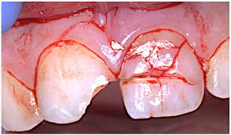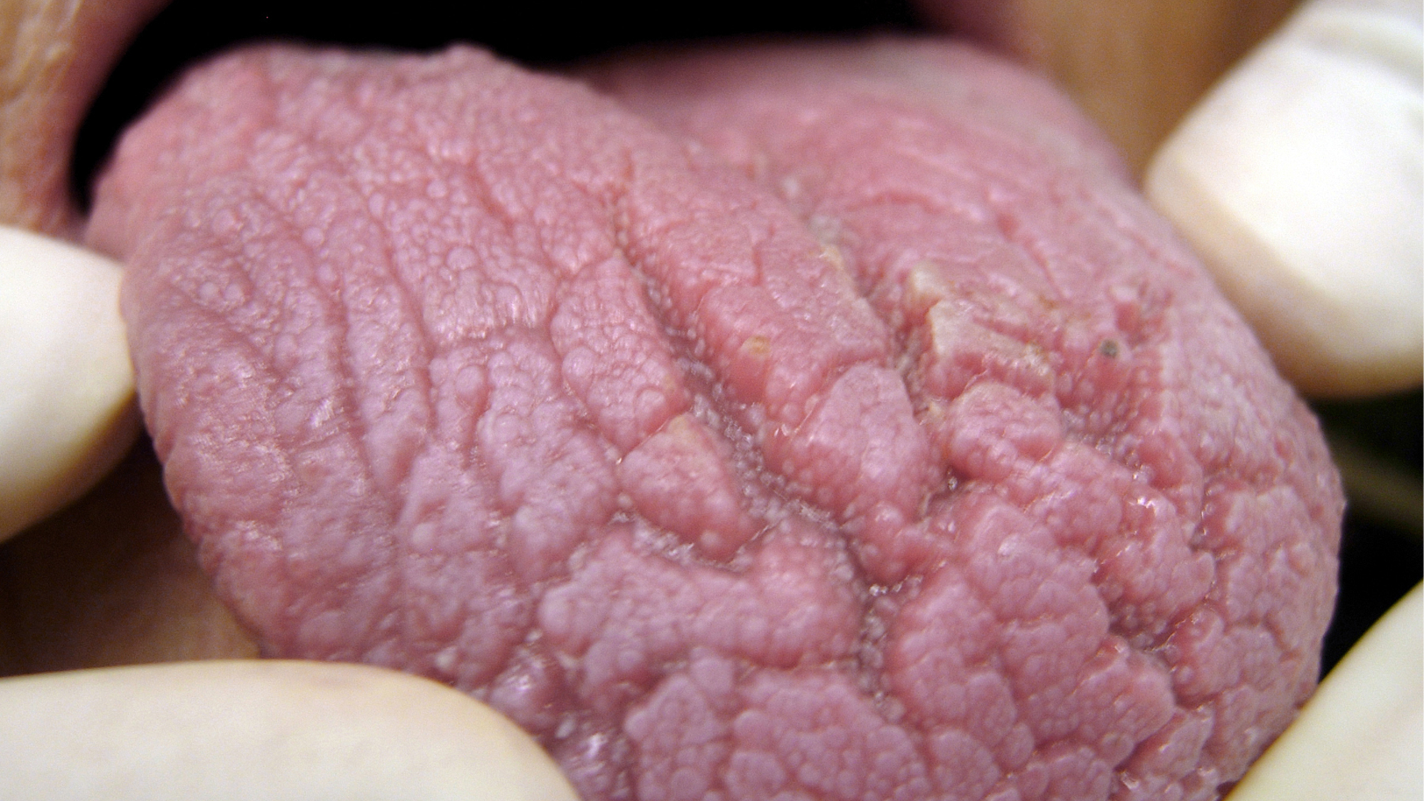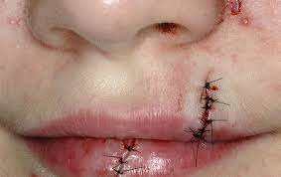
Recreation Therapy
Summary: The client, Generosa Rodrigues is a 32-year-old female evaluated while inpatient as a 939 hospitalization for suicide attempt and mouth injuries. Patient has been given a RT schedule and has been accompanied to groups by her CO.
Special Considerations for RT: Pt has depressive symptoms and needs much emotional support.
Mental Status: Pt was interviewed and was oriented 4x. She demonstrated short term (3/3) and long term (6/6) memory also demonstrated recall (6/6) for an overall cognition score of 15/15. Pt shows some decreasing levels of anxiety since admission, and no significant changes in cognition.
Recreation/Leisure History and Interests: On the leisure interest survey Generosa indicated that she used to enjoy playing basketball and attending basketball games with her children, cooking with her mother, listening to music, and dancing. Constraints to leisure participation include patient’s lack of interest and decline in participation over the past year due to increasing depressive symptoms and recent divorce form her husband, Facilitators to leisure include family members who are supportive of engaging with her in activities, Treatment Considerations: No behavioral issues. Communication clear. Supportive family members (mother, son, 2 daughters) but minimal contact due to COVID-19 restrictions withing the facility. Functional: requires no mobility support.
Tx Plan: Encourage on unit participation
Goal: Promote social connection. RT will meet individually with pt every day with iPad to provide opportunities for pt to connect with family and friends through Facetime, and other social media. RT will provide support and assistance to groups
Goal: Use individual leisure activities to improve mood. RT will meet individually with pt 2x/week to ensure pt has access to skills and supplies for individual leisure activities that can be used to manage or reduce anxiety while in the facility (i.e., deep breathing, music, books).
Physician Assistant Progress Note
Brief HPI:
Pt is a 32-year-old mixed race female admitted to Psych inpatient unit s/p suicide attempt via ingestion of Xanax pills this am. Pt c/o continued suicidal ideation with plan to use a gun to end her life. Pt unable to contract for safety. Pt reports feeling sad, hopeless, with lack of appetite and insomnia x 2 mos. Pt c/o pain and facial swelling with cracked teeth and cuts sustained s/p hitting her face on the bathtub with loss of consciousness after taking undetermined amount of her mother’s Xanax pills. Pt states she is employed as a police officer on FML, recently divorced after a two -year legal battle, and lives with her three children and mother. Pt denies previous psych hospitalizations/admissions.
Interval History:
EMR/chart reviewed and appreciated. Case discussed during morning huddle. Nursing staff reports patient tearful, restless and anxious and continually verbalizing desire to commit suicide upon discharge from hospital. Pt c/o lack of appetite and moderate mouth pain, 4-5/10 due to cracked teeth and sutured lacerations on lips. Pt under constant observation. Will continue to monitor compliance.
Allergies: PCN, NSAIDs
Objective:
BP 100/62 P 112 RR 14 O2 Sat 96% on O2 via NC
Weight 100 lbs. Height 63 inches BMI 25
Mental Status:
Appearance: +facial swelling & intact sutures top & bottom lip, underweight, fragile, fair hygiene & grooming
Behavior: Poor eye contact, cooperative
Psychomotor abnormalities: No psychomotor abnormalities
Speech: Low volume and normal rate
Mood: Anxious, sad
Affect: Congruent with mood
Thought process: Logical
Thought content: Suicidal content
Homicidal ideation: Patient denies aggressive or homicidal ideations
Suicidal ideation: Positive for suicidal ideation
Perceptual abnormalities: No perceptual abnormalities
Insight: Poor
Judgement: Poor judgement based on self-defeating/endangering behavior
Impulse control: Poor
Cognition: Alert and oriented x3, attention and concentration intact
Risk Assessment:
Pt is at moderate to high risk to harm self in the setting of recent suicidal attempt and continued suicidal ideation with intent and a specific plan to commit self-harm. Patient admitted to inpatient psych unit for full stabilization and safe discharge.
Assessment: Depressive disorder with suicidal ideation
Plan
Admitted to Psychiatric inpatient unit
Legal Status: Emergency admission --- 9.39
Justification for Inpatient Care: Danger to self
Psychiatric Management:
Observation status: Close Observation
1. Psychiatric medications and ECT options tbd with team
2. Medical Management:
Monitor vital signs twice daily and behavior changes
Diet: Mechanical soft diet, thin liquids as tolerated
Cracked teeth: f/u Dental Consult
Lip laceration with suture repair
Tooth pain: Tylenol 325 mg po q 6 hrs. prn tooth pain
3. Psychosocial:
Psychotherapy
Milieu therapy
Psychoeducation

Occupational Therapy Discharge Note
Occupational Profile: Generosa is a 32yo Hispanic/White female s/p suicide attempt via attempted overdose of Xanax and suffered mouth trauma during the attempt.
- Occupational History: Prior to admission, Generosa was working as a police officer for NYC. She used to enjoy spending time with her children and mother but has been withdrawn and showed signs of depression for the last year. She has previously enjoyed attending basketball games, cooking, and dancing.
- Social Hx: lives in a two-family house with her 10 yo son, twin 8 yo daughters and mother.
- Contexts that present as potential facilitators: supportive family.
- Contexts that present as potential barriers: factors of the home, work demands, mouth trauma.
Subjective: Generosa reports feeling sad during ADLs and needs much encouragement and assistance to shower. She continues to report feelings of hopelessness.
Objective: Generosa participated in OT session in hospital room. She was AAOx4. Vitals at start of session: HR 78 NSR, BP 130/80, RR 14, Sat 98%
Generosa has participated in Occupational Therapy session only once during her stay on the Psychiatric Unit. She can maintain her ADLs, however, lacks any desire at this time. Her mood continues to present sad.
Assessment: Generosa is capable of independent function.
Plan: Inpatient rehabilitation recommended to facilitate independence with ADLs. Recommend consult with Recreational Therapy for leisure exploration and engagement.
Goals:
- Generosa will engage in self-care independently
- Generosa will maintain her ADLs within 1 week
Certified Peer Recovery Advocate Note

