IPE COVID Discharge Planning Scenario

Patient Summary

Name: Thomas, Ann  Age: 65  DOB: 3/5/1955  MRN: 5054010  DNR: No  Inpatient Healthcare  Proxy: Yes  Admitting weight 204 lbs.  Height: 64 inches  BMI: 34  PMH: COVID-19 Pneumonia; Right Cerebral Vascular Accident (CVA); Obesity; Type II Diabetes Mellitus (NIDDM), Hypertension, Osteoarthritis (OA) bilateral knees.  PSH: Bilateral total knee replacements (TKR) | DEMOGRAPHICS  Gender Identity: Female  Religion: Catholic  Household Members: Husband, daughter and one grandchild  Occupation: Retired secretary  Marital Status: Married  Race/Ethnicity: Hispanic  Primary language: English  Postal Code:10455 (Bronx)  Other: Husband lost his deli business during COVID pandemic | ALLERGIES: NONE  Current MEDICATIONS:  Dexamethasone 20mg by mouth daily (anti-inflammatory)  Enalapril 2.5 mg by mouth daily (hypertension) Aspirin 81 mg by mouth daily (circulation)  Metoprolol 25mg twice a day by mouth (hypertension) Heparin SQ 5,000 Units 2 x day (prevents clots) Pantoprazole 40mg daily by mouth (treats and prevents acid reflux) Colace 100mg twice a day by mouth as needed for constipation (stool softener)  Tylenol 650mg by mouth as needed for pain for pain level >3  Alprazolam .25mg by mouth 3 x daily as needed for anxiety  Metformin 500mg once daily by mouth (NIDDM)  Ensure Plus 1-2 cans daily (nutritional supplement)  Oxygen 2 lpm via nc as needed for pulse-ox <92
Current History of Present Illness:
65-year-old person identifying as Hispanic female initially presented to the Emergency Department with severe shortness of breath, loss of smell, oral temperature of 102.4 and fasting blood sugar 245. The patient quickly decompensated with a 0₂ saturation of 78% and Venturi mask 15 l/m ordered. She was admitted to the COVID ICU approximately 8 days ago and Dexamethasone plus remdesivir was immediately started based upon her eligibility. Testing for SARS-CoV-2 came back positive, confirming COVID-19 pneumonia. Patient is also s/p right CVA just prior to this hospitalization with exacerbation in her dysphagia and right sided weakness noted; therapy services provided.
Due to early antiviral treatment, the patient’s four-day ICU stay was unremarkable: she was weaned to O₂ 4 lpm and transferred to the medical unit for the past 4 days. She is now tolerating room air but has oxygen ordered at 2 liters per minute for pulse-ox <92%. Last fasting sugar 84. The doctor has evaluated the patient and has ordered her to be discharged from the hospital to either home or an inpatient rehab facility. Patient is expressing fear and anxiety in returning home and does not feel ready to be discharged. Her interprofessional team is meeting to discuss her discharge plan of care.
PAST MEDICAL HISTORY:
COVID-19 Pneumonia; Right CVA; HTN, NIDDM, OA, Obesity, Bilateral knee replacements
SOCIAL HISTORY:
Patient with new cognitive deficits. Lives with spouse in an elevator building with 3 steps to enter. Recently retired. Spouse recently lost deli business during COVID. Social drinker with friends now & then. Has 2 grown children and 3 grandchildren. Daughter and 1 grandchild also live with patient.
PROGRESS NOTES (ASSESSMENT AND EVALUATION FROM EACH DISCIPLINE)
PHYSICIAL THERAPY EVALUATION
Objective:
Mental Status: Pt cooperative. A&O x 4
Integumentary: skin intact
Compression stockings in place
+ IV, 2L O₂ via NC
Vital Signs: HR 78 NSR, BP 130/80, RR 14, Sat 95% on 2 L O₂
Pulmonary: Slightly diminished breath sounds at bilateral bases with mild crackles
Reflexes – L LE 3+, Modified Ashworth Tone 0
RLE ROM WFL, MMT >/= 3/5 T/O
RUE ROM WFL, MMT >/= 3/5 T/O, Grip strength 22Kg
LLE PROM WFL except L ankle DF = 0 degrees. AROM presents w/ partial control of hip and knee with no active control of the left ankle. MMT at hip and knee = 3-/5.
LUE PROM WFLs, LUE AROM shoulder flexion to 90, partial active movement noted through elbow, wrist, and hand. Partial active control in fingers.
Supine to Sit with CGA/supervision due to perceptual and attention deficits. Patient able to tolerate sitting EOB x 15 min with stable hemodynamic response
Sit to Stand with CGA
Transfer bed to chair requires min A
5 X times sit to stand: 20 seconds
Amb 50’ with SBQC with CGA. Left foot drop. Pt reports SOB upon ambulation. O₂ Saturation decreased to 91 with ambulation
IS to 300 x 10. Increased O₂ Saturation to 96
Pt. left seated in bedside chair. VS stable

Assessment: Pt presents s/p ARDS and R CVA with good rehab potential. Pt able to follow simple commands. Pt has demonstrated improvement but has limited activity tolerance still requiring assistance for functional mobility skills of bed mobility, transfers, and ambulation due to L sided weakness, balance impairments, and limited pulmonary capacity. Pt has risk of falls due to perceptual deficits, limited balance, LE weakness, and results of 5x sit-to-stand test. Expect pt to make good progress with daily PT to increase safety and mobility skills. Recommend DC to in-patient rehab. Recommend continued OT & SLP.

Long Term Goals: Pt will be I in bed mobility and sit to stand in 1 week. Pt with require CGA for bed to chair transfer in 1 week. Pt will amb 150’ w/ S due to foot drop in 1 week; AFO recommended; evaluate stair negotiation as appropriate. P&O evaluation recommended.
Plan: Daily PT to include deep breathing exercises, functional mobility training, balance training, ther ex. Recommend L AFO. To assess for stair negotiation as tolerated.

NUTRITION ASSESSMENT NOTE

Pt visited for follow-up on po intake, diet consistency and body weight.
Pt reports NKFA and no weight changes PTA, consuming a regular diet with no restrictions. She prepared food herself. Reports some swallowing difficulties but insists she “can handle” the food as provided, appreciates the recent advancement to thin liquids. Noted some difficulty with articulation during conversation.

Current diet order: Pt currently receives mechanical soft diet with thin liquids (IDDSI 6/0), with one can Ensure plus daily (240cc, providing 355kcal and 13g protein).
Dx: Pt is s/p ARDS with mechanical ventilation, and s/p CVA with left hemiparesis.
PMH: HTN
NFPA: Abdomen soft, non-distended, + bowel sounds per Nsg, skin intact per Nsg, no muscle or subcutaneous fat wasting noted upon visual examination and palpation of face, shoulders, and arms.
Current labs: not available
Current nutrition-related drugs: Pantoprazole, Colace
Current weight: 190 lbs, BMI: 25.7 – overweight; height 64 inches
EER: 1705 – 2045kcal/d based on 25-30kcal/kg
Protein requirement: 102-136g/d based on 1.5-2.0g/kg,
Fluid requirement: 1705-2045cc/d based on 30cc/kg

Nutrition Diagnoses:
Difficulty swallowing RT decreased function 2’ R CVA AEB SLP assessment and pt report of tolerating mechanical soft diet (IDDSI level 6)
Inadequate oral intake RT food preferences AEB pt report and Nsg record of intake at 50-75% of food served. Impairments in self-care RT limited functional skill 2’ R CVA AEB assessment by PT

Nutrition Interventions:
Continue Mechanical soft diet, thin liquids (IDDSI 6/0), per SLP recommendation and MD order,
Recommend high protein, high energy, low salt (provides 4g NaCl/d, 4g potassium per day) diet,
Provide feeding assistance
Honor patient’s food preferences
Recommend consult with OT for adaptive feeding tools

Goals continue:
Maintain body weight.
Increase intake to 75-100% of foods served.
Tolerate diet consistency.
Continue Ensure Plus daily.

Monitoring/Evaluation continue:
Monitor oral intake,
Monitor body weight
Monitor for S&S of aspiration during eating
Monitor labs as available
NURSING Assessment Report

Situation: Patient is being considered for discharge to rehabilitation facility or home care. She can breathe on 2 liters of nasal cannula, her O₂ saturation is 95% on room air with no difficulty breathing, her respiratory rate is 20 per minute, her heart rate is 72 and her blood pressure is 140/90. She is tolerating a soft diet and progressing to an easy to chew diet as tolerated. She can ambulate with assistance.
Background: She has a history of hypertension for several years that is controlled with medication. Her admitting B/P to ED was 160/100, RR32, PR 110. She was subsequently diagnosed with COVID-19 with respiratory failure requiring intubation. She was admitted to the Intensive Care Unit x 10 days. During her ICU stay, she had a Right Cerebroovascular Accident. After extubation, she was transferred to the medical unit.
Assessment She is fearful and very anxious about returning to her home and will require rehabilitation services. Her vital signs currently are B/P 140/90, RR 20, PR 72 and Stable. She is breathing comfortably with 2L/0₂. She has tested positive for COVID 19. She continues with left hemiparesis weakness.
Recommendation: She will need rehabilitative services from the interprofessional team: Speech, Physical Therapy, and Social Work and Registered Dietician services and possibly home care services after her discharge.
If returning home, family will need education about financial resources, insulin administration, post-COVID care include infection control measures and vaccine education. May need home health aide services (HHA). HHA can provide hands-on care for patient and assist with Activities of Daily Living (ADLs) (bathing, eating, ambulating, dressing, meal prep and light housekeeping).
SOCIAL WORK INPATIENT-ICU PROGRESS NOTE:

Social work met with patient (Ann) and spouse (Paul) together (virtually) for an initial assessment and subsequently met with each of them separately to provide individualized psychosocial support. Ann is a 65 yo female who lives with her 67 yo spouse in an elevator-accessible building with three steps to enter. Ann and her husband have been married for 30+ years. Both shared that it has been extremely difficult to be separated from one another. In addition to concerns about Ann’s recovery, they are each deeply worried about one another. Paul was working full-time outside the home, but recently lost the family’s deli business. This loss, along with not being able to be with his wife in person, and significant changes to roles and responsibilities has contributed to both of their reported distress. Prior to admission, the patient was independent and worked as an administrative assistant. Patient was self-quarantined for five days prior to her ED admission due to secondary to exposure to her COVID-positive granddaughter visiting from college.

Paul states that he will be home as he figures out what his plan is for income. Ann and Paul did express anxiety about their finances, but they reported that they have some savings. Ann is eligible to receive short-term disability from her job. She expressed that she would like to return to work but is open to retiring as well. Upon retirement, she stated she will receive some benefits from her job. If Ann were to retire at the end of short-term disability, she should be eligible for both Medicare and Social Security. Since Ann and her husband currently have health insurance through her employer, neither she nor her spouse have applied for Medicare. The short-term disability will cover up to 6 months, which she has been paying into from her income. This might allow her to continue to receive non-COBRA health care insurance for this period. Patient and/or family to call HR at patient’s job to confirm and discuss short-term and long-term options. Ann’s husband is 67 years old and is eligible for social security and Medicare. Social work discussed options at length with patient and husband and provided phone numbers and websites to consult. Social work outlined Medicare coverage and options to ensure full coverage. Social work helped patient and husband with some questions to ask HR and offered to assist with this or any other part of the process as needed. Patient’s spouse reports that he is in good health and has not tested positive for COVID-19.

Ann has two adult children and 3 grandchildren. One of the patient’s adult children and patient’s granddaughter live with the patient and her spouse. Ann’s daughter works full-time; however, during COVID, the daughter has been working from home. The patient’s other daughter and her two grandchildren also live near the patient.
The patient has reported that she is a social drinker and does not take any drugs other than prescribed medications. She reports that she has been in therapy in the past for depression and anxiety but was not seeing a therapist at the time of admission. She stated that she would be open to speaking to a therapist remotely upon discharge and has internet access and video capabilities at home.

Patient reported difficulty coping with her loss of independence. The social worker administered the 7-item Generalized Anxiety Disorder (GAD-7) and the 9-item Patient Health Questionnaire (PHQ-9). The patient fell within the severe range on both the GAD-7 (anxiety) and the PHQ-9 (depression). Due to Ann’s stroke and the ongoing cognitive assessment, these measures should be readministered upon discharge. Some of the responses could be related to the significant loss of independence. However, the patient reported some pre-existing depression and anxiety that has been exacerbated by her current situation. Social work discussed short-term goals with the patient which includes returning home and regaining her independence. Her longer-term goals are to return to work and to maintain her health. The patient’s spouse reports increased anxiety and would benefit from emotional support as well. Social work recommends ongoing therapy to address, loss, depression, traumatic stress, and anxiety. Patient did not express any suicidal ideations, intentions, or plans. Social work will continue to provide emotional support throughout admission and speak with patient and spouse about ongoing support upon discharge. Social work, in consultation with the entire medical team, will continue to work with the patient and family to ensure referral to appropriate resources and provide ongoing support.

SOCIAL WORK DISCHARGE NOTE
Social work continues to meet with the patient (Ann) and her family to provide support, using a trauma-informed and healing centered approach, while she has been an inpatient and to discuss options for next level of care. The social worker will continue to work with the other professionals on the team to secure assistance, discuss options, and make referrals for recommended services upon discharge. Patient and husband would prefer patient go to an acute rehab over SNF as they do not want patient to go to a nursing home. Social work provided patient and husband with a list of facilities and will make referrals based on team recommendations and the preference of patient and family.

Social work continues to discuss financial, insurance, and disability coverage options with both patient and husband. As per previous discussions, Ann, and Paul (husband) called HR at the patient’s job. They confirmed that she will be able to receive non-COBRA health insurance for the 6 months she is on short-term disability. Ann seems to be leaning towards retiring at the end of her short-term disability coverage and enrolling in Medicare, in addition to receiving Social Security. Upon retirement, Ann would also receive a portion of her current income from her employer. If Ann chooses retirement, her husband will also enroll in Medicare and receive Social Security.

It is recommended that the patient receive individual counseling once per week to help her process the changes that have occurred in her life. She will need to focus on the lifestyle modifications that will be necessary to accomplish her daily routines and activities of daily living. At least ten sessions are recommended to start. Additionally, three or four family sessions are recommended to discuss the Ann’s needs and how they can all work together to support each other and maintain family functionality. Ann and her family will continue to discuss how the tasks normally done by Ann will be distributed between family members. A list of supportive resources will be provided to Ann to assist her and her family. An online support group needs to be found to connect Ann with others facing similar circumstances. This can become a referral to a program once the COVID-19 restrictions have been lifted.

Transportation resources will be identified to help Ann get to appointments and other activities. Social work will continue to provide emotional support throughout the remainder of her inpatient stay. Social work, in consultation with the entire medical team, will continue to work with the patient and family to ensure referrals to appropriate level of care, resources and to sources that can provide ongoing emotional and psychological support.
SPEECH LANGUAGE PATHOLOGY DISCHARGE NOTE

Subjective: Ann was cooperative during all SLP sessions. Sessions were occasionally limited due to Ann’s fatigue and anxiety regarding her discharge plan. Ann denied history of speech, language, cognitive and swallowing difficulty prior to hospitalization and reported she was tolerating regular texture diet with thin liquids at home.

Objective:
Oral Motor Evaluation: Patient has full natural dentition. No overt weakness or incoordination noted during most recent oral motor exam. Adequate ROM for all structures.

Swallowing: Ann demonstrated mild oropharyngeal dysphagia following extubation most likely due to suspected laryngeal edema, overall deconditioning, and fatigue. Her mastication was slow and effortful. Mild residue was noted in her oral cavity following the swallow, which cleared with a subsequent swallow and use of a liquid wash. Delayed pharyngeal swallow initiation was palpated. Delayed cough response noted after sips of thin liquids. Clear vocal quality throughout all PO trials. Ann was started on pureed texture diet with nectar liquids via controlled cup sips [IDDSI 4/1] two days following extubation. Ann was advanced to soft texture diet with thin liquids [IDDSI 6/0] one week later after participating in an MBS objective swallow study as improved mastication and swallow timing were observed. At time of discharge, Ann is tolerated soft texture diet with thin liquids via small, controlled cup sips. However, Ann was observed to be impulsive during self-feeding and required occasional verbal cues and intermittent supervision to implement safe swallow strategies to reduce aspiration/choking risk. Education was provided regarding use of safe swallow strategies to reduce aspiration risk including positioning upright to 90 degrees when eating/drinking/taking medications, small bites/sips, alternating solids/liquids during meals and avoiding straws.

Voice: Mildly hoarse vocal quality was noted immediately following extubation. However, dysphonia resolved within 2-3 days. Clear, strong vocal quality noted at time of discharge.

Speech intelligibility: Speech was 80% intelligible to an unfamiliar listener. Mild dysarthria characterized by slow speech rate and decreased articulatory precision. Noted to be improving throughout hospitalization. Further assessment and treatment warranted following discharge from acute care.

Expressive and receptive language skills: Ann follows multistep directions, answers yes/no questions and simple open-ended questions during conversation independently. She also communicates her wants/needs/ideas independently fluently with appropriate grammatical structure and without evidence of anomia, jargon and/or paraphasia. However, discourse-level impairments were noted including tangential comments, disorganized narratives, and reduced ability to identify and repair conversational breakdowns. She also demonstrated difficulty with interpreting and using figurative/nonliteral language (e.g., humor, sarcasm). Reading and writing skills were not assessed during her acute hospital stay. Further assessment of higher-level language skills and reading and writing is warranted.

Cognitive-communication skills: Mild cognitive-communication deficits were noted in the areas of attention, higher-level problem solving and safety awareness. Anne was observed to be impulsive at times and required frequent verbal cues to implement safety strategies such as using the call bell to ask for assistance to go to the bathroom and using safe swallow strategies during meals.

Pragmatics: Appropriate social greetings, facial affect, and eye contact. Mild aprosodia noted.

Summary of goals targeted during acute-care stay:
- Ann will tolerate least restrictive diet without overt signs/symptoms of aspiration or evidence of impaired airway protection. – NOT MET, soft texture with thin liquids
- Ann will implement strategies to improve swallow safety / reduce aspiration and choking risk during all PO intake, given cues <25% of time. – NOT MET
- Ann will complete room-based functional problem-solving tasks (e.g., use of call bell) with 80% success, given cues <25% of the time. – MET, recommend targeting problem-solving tasks pertaining to community reintegration (e.g., money management, route finding, sequencing)
- Ann will successfully modify prosodic contours (e.g., rising intonation for questions) in at least 80% of opportunities during structured tasks given cues <25% of the time. – MET, recommend targeting prosodic contours in more naturalistic contexts

Assessment/Plan
Ann presents with mild cognitive-communication disorder characterized by impulsivity, decreased insight/safety awareness, aprosodia and decreased organization of verbal output. Her post-extubation dysphagia has improved and her diet was advanced to soft texture and thin liquids [IDDSI 6/0]. However, she remains at increased risk for aspiration due to impulsivity when self-feeding and supervision needed to implement aspiration precautions. Given PLOF, Ann is expected to make good progress with ongoing SLP services targeting improving cognitive-communication skills and increasing independence with using safe swallow strategies to reduce aspiration risks. Recommend ongoing assessment of higher-level communication skills and reading/writing. Recommend DC to rehab vs. home with supervision and outpatient SLP services.
DENTAL/ORAL HEALTH NOTE
• Chief Complaint: patient reports discomfort in the mouth, difficulty swallowing, frequent coughing. Upon admission, patient noted loss of taste and smell which is still persistent.
• Extraoral Examination: No facial swelling. Facial asymmetry related to right CVA stroke
• Intraoral Examination: No hard tissue or soft tissue trauma noted from intubation. Periodontal disease (Stage II, Grade B) complicated by Type II Diabetes Mellitus. Mild residues noted in oral cavity (food rumination), patient can clear the food with intake of water. Palatal lesion noted as a red flat lesion starting in the soft palate extending anteriorly to the hard palate. Patient chief complaint is “mouth is sore and has a sour taste.”
• Assessed that patient has difficulty swallowing, recommend consult with OT/SP
- Xerostomia noted
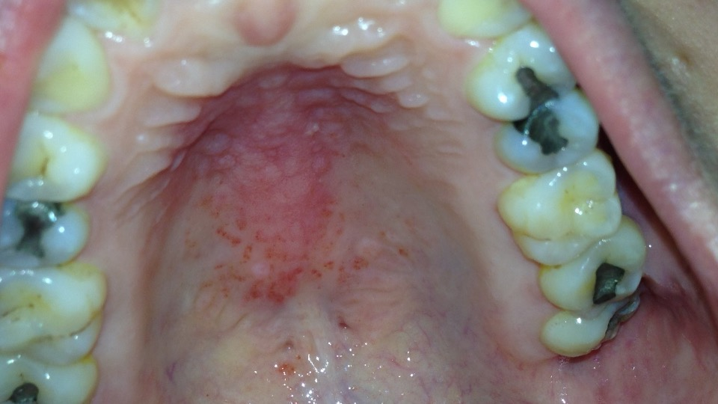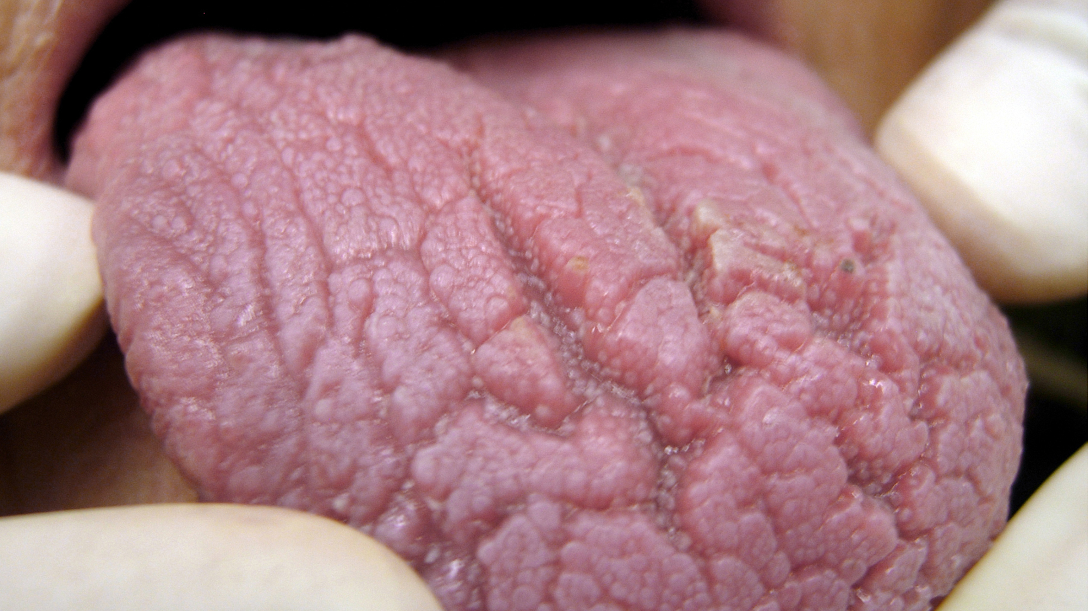
RECREATIONAL THERAPY NOTE

RECREATIONAL THERAPY
Summary: The client, Ann Thomas is a 65-year-old female being discharged to a skilled nursing facility from a hospitalization for COVID-19 and a Cerebral Vascular Accident. Prior to discharge the Bandi-RT was administered. Results indicate pt will benefit from both group and individual recreational therapy after discharge to the rehabilitation facility.

BANDI-RT
Special Considerations for RT: Pt has a fall risk and left-sided weakness. Pt is on a special diet due to difficulty dieting and hx of diabetes. No hx of seizures. Notable medications include anti-anxiety, antidepressant and anticoagulant, and precautions should be taken for potential medication-related sun sensitivity. Mental Status: Pt was interviewed and was oriented 4x. She demonstrated adequate short term (3/3) and long term (6/6) memory but demonstrated poor recall (3/6) for an overall cognition score of 12/15. Pt shows higher levels of anxiety since initial discharge, but no significant changes in cognition.
Recreation/Leisure History and Interests: On the leisure interest survey Ann indicated that she used to enjoy playing softball and attending baseball games, attending religious services, making jewelry, listening to music, and dancing. Constraints to leisure participation include limited opportunities to engage with the community due to the ongoing pandemic. Facilitators to leisure include family members who are supportive of engaging with her in activities, access to technology including a smart phone, computer, and Nintendo switch, access to games and craft supplies. Treatment Considerations: No behavioral issues. Communication issues include mild aphasia, word finding problems. Supportive family members (husband, daughter, grandchildren) but low contact due to COVID-19 restrictions within the facility. Functional: requires mobility support.

Tx Plan:
Goal: Improve strength and endurance. RT will work with pt in physically active recreation groups such as yoga, chair Zumba, and WiiFit to promote increased sitting endurance, and improved upper body strength focused on the left hemiparesis.
Goal: Promote social connection. RT will meet individually with pt every day with iPad to provide opportunities for pt to connect with family and friends through Facetime, and other social media. RT will provide technical assistance as required.
Goal: Use individual leisure activities to improve mood. RT will meet individually with pt 2x/week to ensure pt has access to skills and supplies for individual leisure activities that can be used to manage or reduce anxiety while in the facility (i.e., deep breathing, music, books).

OCCUPATIONAL THERAPY DISCHARGE NOTE
Occupational Profile: Ann is a 65yo Hispanic female s/p COVID-19, ARDs, s/p RCVA w/ L hemiparesis. PMH: HTN.
- Occupational History: Prior to admission, Ann was working as a secretary. She enjoys spending time with her grandchildren and occasionally helped with childcare as needed. She also has previously enjoyed attending baseball games, making jewelry, and dancing.
- Social Hx: lives in elevator building with husband, one adult daughter and granddaughter. Additional adult daughter and grandchildren live nearby.
- Contexts that present as potential facilitators: supportive family, supportive church community.
- Contexts that present as potential barriers: environmental factors of the home, work demands, needs for DME and adaptive equipment.
Subjective: Ann reports feeling tired easily during ADLs. She continues to report feelings of sadness and missing her family members.

Objective: Ann participated in OT session in hospital room. She was AAOx4. Vitals at start of session: HR 78 NSR, BP 130/80, RR 14, Sat 95% on 2 L O₂
RUE AROM WFLs, MMT = 3/5 throughout, grip strength 22kg; LUE PROM WFLs, LUE AROM shoulder flexion to 90, partial active movement noted through elbow, wrist, and hand. Partial active movement noted in fingers with decreased coordination of movement noted throughout LUE. Ann continues to demonstrate perceptual deficits and requires verbal prompts to locate items to the left of midline and to incorporate LUE during ADLs. She also demonstrates decreased attention, impulsivity, and decreased safety awareness during ADLs and functional mobility.

Ann has participated in daily Occupational Therapy sessions during her stay on the Med/Surg Unit. She can complete grooming to wash her face with minimal assistance after set-up with occasional verbal prompts for thoroughness especially left of midline. She can don a button-down shirt with moderate assistance. She can don pajama pants with moderate assistance. She continues to require verbal prompts to “look to the left” and for safety awareness during ADLs. She can transfer from bed to bedside commode with Min A w SBQC and verbal prompts for safety.

Assessment: Ann has made progress to improve her performance with ADLs and functional mobility; however, she continues to require Min-Mod Assistance with ADLs, and Min A with SBQC for functional transfers. In addition, she continues to require supervision and verbal prompts for safety due to impulsivity, decreased attention, and perceptual deficits with LUE. Ann demonstrates potential to continue to improve her independence with ADLs and IADLs.

Plan: Inpatient rehabilitation is recommended to facilitate independence with ADLs, IADLs, and promote safety awareness prior to return home. Further assessment of IADLs and home safety check are also recommended prior to discharge home. Recommend continued OT to focus on facilitating independence with ADLs and IADLs, patient/family education and training for safety and compensatory strategies for ADLs and IADLs, and neuromuscular re-education to incorporate LUE as functional assist during ADLs and IADLs. Recommend consult with Recreational Therapy for leisure exploration and engagement.

Goals:
- Ann will complete grooming activities independently after set-up within 1 week.
- Ann will don a button-down shirt with minimal assistance after set-up within 1 week.
- Ann will incorporate 2/2 compensatory strategies with minimal verbal prompts to improve ability with perceptual deficits during ADLs within 1 week.
- Ann will incorporate her LUE as a functional assist during ADLs with minimal assistance within 1 week.
PHYSICIAN ASSISTANT ASSESSMENT

